** Please do **not** change the name of the folders. **

## **Introduction**

<TODO: Link to document explaining what *MDS Validation* means and all the rules, logic>

Validation of MDS Episode data has been moved to the cloud i.e. the Microsoft Azure platform. This means the validator tool can be run by anyone who is able to access the SharePoint folder: [MDS Validation Folder](https://directionshealth.sharepoint.com/Reporting/Forms/AllItems.aspx)

There are **4 folders** you would need to understand:

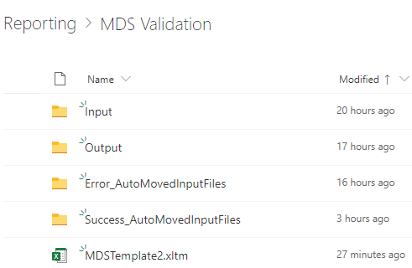

1. **Input folder** is where you place the file you want to validate. Once it has been picked up by the validator process, it will disappear from there and be moved into a Success/Error folder.
2. **Output folder** is where the result of the validated file is placed. It bears the same filename and extension (.csv) as the input file. Output files have alternate columns that may have error messages corresponding to the field to the left of them.
3. **Success_AutoMovedInputFiles:** On successful processing (i.e. the expected columns and naming convention were correct, but there may be MDS Validation errors), the input file is moved from the Input folder to this one.
4. **Error_AutoMovedInputFiles:** If there was a problem before the validation could start, the input file and another file called ***error_<input-filename>.csv*** is placed in this folder. This error file is what you would use to diagnose and fix any errors before retrying validation.

## **Validation Process**

### **Steps**

1. Make sure the input file is in an acceptable format in a .csv file. Also, for the file to be picked up by the validator process it needs to follow a specific naming convention as well as a data format. An example of a valid data format: Communicare report: *AOD Enrolments and exits*.
2. Copy & Paste (or drag ‘n drop) the .csv file into the **Input** folder of the aforementioned SharePoint directory.
3. Wait for a minute and check the Output folder. (the validation app checks the /**input** folder **every 30 seconds**, and if all goes well runs the validation and creates the output file)
   1. If you see a file with the same name as your input file and the modified date is recent, you can download the file for analysis. Note: your input file would’ve been moved to the folder: [Success_AutoMovedInputFiles](https://directionshealth.sharepoint.com/:w:/g/ER2nM84OAntHoJJ0fJJuYvoBHwP0ErGa-fGCCDp7BYtCZA?e=5MtbmP)
   2. If your file is absent, check the folder: [Error_AutoMovedInputFiles](https://directionshealth.sharepoint.com/:w:/g/ER2nM84OAntHoJJ0fJJuYvoBHwP0ErGa-fGCCDp7BYtCZA?e=5MtbmP)

### **Viewing errors in a Formatted Excel template**

After successfully downloading the output .csv file, open the **MDSTemplate2.xltm** file (Excel Template with Macros). You may need to click on “Enable editing” and then “Enable macros” on the yellow bar comes up (only the first time, if you have saved the file on your PC).

Press **Ctrl + Shift + D** and Excel will ask you to select a csv file for input. Choose the downloaded file and click Open. If you don’t see the data in the alternate-colour-coded table, click on the 2nd sheet and return to the “loaded” one and you will see the pop-up. If nothing happens even then, try pressing **Ctrl + Shift + C** and the repeating the above steps. Once the data from the output .csv is successfully imported; you can save the formatted file for team leaders to view them.

## **Acceptable Input File Format**

#### **Naming Convention**

The file you drop into the input folder must have the following format:

<ProgramName>**_**<**Month**Year>**_**<***Period***>.csv

This format can optionally be prefixed with any arbitrary string of characters as long as there is an underscore (‘**_**’) preceding the ProgramName.

* Valid **Program Names**: TSS, Althea, ArcadiaResi, Mastercare
* **Month Year** : *072019* or *122018* start of the period (1st day is assumed)
* **Period** : ***1*** , ***3***, ***6***, ***12*** – for monthly, quarterly, half-yearly, annual

Example: (1 Oct to 31st Dec 2019)

#### **File Contents**

**Required Headers (columns):**

1. Demographic Details

ID, SLK 581, Sex, DOB, Date accuracy indicator, Country of birth, Postcode (Australian),

Indigenous status, Preferred language

1. Episode Details

Commencement date, End date, Client type, Principle drug of concern, ODC1, ODC2, ODC3, ODC4, ODC5,

Main treatment type, OTT1, OTT2, OTT3, OTT4, Reason for cessation,

Method of use for PDC, Usual accommodation, Living arrangements,

Injecting drug use status, Treatment delivery setting, Source of referral,

Mental health, Previous alcohol and other drug treatment received

**Other Important things to note:**

* The fields (headers) within the input file could have Alternate names ([aliases](https://github.com/dactechie/MDSValidator_AZFunc/blob/master/MDSValidator_HttpTrigger/MDSValidator/AOD_MDS/aliases.py)) on any fields.
* There may be other fields, but those would be **ignored**.
* There should not be any **gaps** in the rows, or column headers.
* No **extra rows** should be present – For example dropdown lists starting from row 500 in the Goulburn Data Collection spreadsheet.

### **Convenience**

You can map the MDS Validation folder to your desktop (OneDrive app), by clicking on the “Sync” button on SharePoint. This would reduce the number of steps need and eliminate the need to keep the browser open on the SharePoint folder.

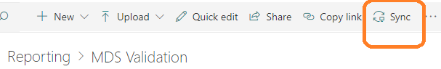

**MDS Validator Output fields:** ENROLLING PROVIDER, ID, First name, Surname, EID, SLK 581,Sex,DOB,Date accuracy indicator, Country of birth, Indigenous status, Preferred language, Postcode (Australian),Usual accommodation, Client type, Source of referral, Commencement date, End date, Reason for cessation, Treatment delivery setting, Method of use for PDC, Injecting drug use status, Principle drug of concern,ODC1,ODC2,ODC3,ODC4,ODC5, Main treatment type,OTT1,OTT2,OTT3,OTT4,Living arrangements, Previous alcohol and other drug treatment received, Mental health

## **Admin Users**

[MDSValidator Logic App](https://portal.azure.com/#@directionshealth.com/resource/subscriptions/e1a42143-a624-4e4e-809d-d1271b8b0d29/resourceGroups/mds/providers/Microsoft.Logic/workflows/MDSValidatorApp/logicApp) (requires you to login with the directions.admin account). You can also get here from portal.azure.com and then click on “All Resources”

Click on “edit” to make changes to the Logic App. The very last step (click on each box to expand) sends an email. You can change this, so **you** get notified when the process is successfully complete.

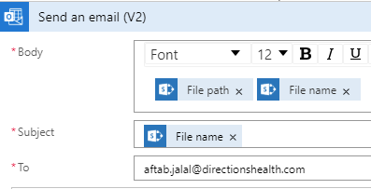

### **Manually triggering the process**

After placing the file in the input folder, you can click on **Run Trigger.**

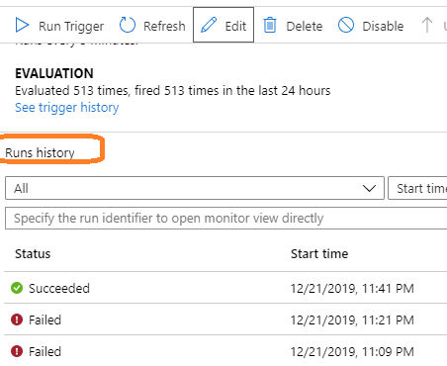

You will see the execution as it progresses through the workflow steps. Click on “Failed” (image below) to investigate failures. AZ Function MDSValidator code is [here](https://github.com/dactechie/MDSValidator_AZFunc). See Developer Guide.